
NORTHERN EDUCATION DIVISION
2023 MSCE MOCK EXAMINATION
PHYSICS
Thursday, 23 March Subject Number: M164/1
Time allowed: 2 hours
08:00 – 10:00 am
PAPER I
(100 marks)
Theory
Question Number | Tick if answered | Do not write in these columns
1
2
3
4
5
6
7
8
9
10
11
12
13
Instructions
- This paper contains 14 printed pages. Please check.
- Before beginning to answer these questions write your Full Name in the spaces provided at the top of every page of the question paper.
- This paper has two sections, A and B. in section A there are ten short answer questions while in Section B there are three essay questions.
- Answer all the thirteen questions in the spaces provided.
- Use of electronic calculators is allowed
- In the table provided on this page, tick against the number of the question you have answered.
- Hand in your completed question paper when time is called to stop writing.

Section A (70 marks)
- a. Define the term pitch of sound.
____________________________________________________________________________________________________________________________________ (1 mark)
b. Explain how pitch of sound is affected by frequency of a vibrating object.
____________________________________________________________________________________________________________________________________________
(2 marks)
c. How is sound propagated?
____________________________________________________________________________________________________________________________________ (1 mark)
d. A girl standing 1000m from a cliff blows a whistle once. The girl hears the echo of sound produced by the whistle after 6 seconds. Calculate the speed of sound in air.

(3 marks)
- a. i. Give one use of magnets in hospitals
_______________________________________________________________ (1 mark)
ii. State the Faraday’s law of electromagnetic induction. ______________________________________________________________________________________________________________________________________ (1 mark)
b. Why is alternating current not recommended in making of magnets?
______________________________________________________________________________________________________________________________________ (1 mark)
2. continued;
c. Mention one difference between step–up and step–down transformers. ______________________________________________________________________________________________________________________________________ (1 mark)
d. Describe how a steel bar can be magnetized using two permanent bar magnets. ____________________________________________________________________________________________________________________________________________________________________________________________________________________________________________________________________________________________
(3 marks)
- a. A heating element is captioned “1000W, 240V”. What does this mean about the element?
____________________________________________________________________________________________________________________________________ (1 mark)
b. The electrical energy consumption for Madam Katakwi is shown in the following table. Use the information to answer questions that follow:
Madam Katakwi Details
Previous meter reading | Current meter reading | Cost per unit (MK) | VAT
82777 | 82915 | 60.00 | 16.5%
- Calculate total consumption for madam Katakwi.
___________________________________________________________ (1 mark)
ii. Calculate total bill to be paid by madam Katakwi including VAT.

(3 marks)
- a. What is the difference between absolute temperature and absolute zero temperature?
________________________________________________________________________________________________________________________________________________________________________________________________________________________________________________________________________________________
(2 marks)
b. Explain the cause of gas pressure.
____________________________________________________________________________________________________________________________________ (1 mark)
c. Derive the formula for liquid pressure P = dhg

(4 marks)

- a. Figure 1 is a diagram of a measuring instrument
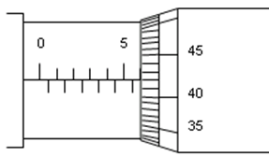
Figure 1
- Name the instrument.
______________________________________________________________ (1 mark)
- Find the reading as shown by the instrument.

(2 marks)
- Write 0.065 in standard notation.
______________________________________________________________ (1 mark)
b. Explain the importance of experimental conclusion.
____________________________________________________________________________________________________________________________________________
(1 mark)
c. Mention the first two components of a laboratory report.
____________________________________________________________________________________________________________________________________________
(2 marks)

- a. Mention any two applications of moment of a force.
____________________________________________________________________________________________________________________________________________
(2 marks)
b. Figure 2 shows a spanner being used to tighten a nut.
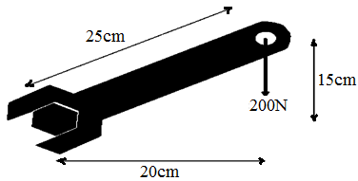
Figure 2
Calculate the moment being applied to the nut, leaving your answer in newton–meter.

(3 marks)
c. A ball tied to a string is rotated at uniform speed in a circle of radius 10cm. It takes 3 seconds to describe an arc of length 12cm. Calculate angular velocity.

(2 marks)
- a. Name any one characteristic of radioactive materials.
____________________________________________________________________________________________________________________________________ (1 mark)
- Table 1 shows the activity of a radioactive element with.
Activity (Disintegrations/sec) | 40 | 30 | 20 | 10
Time (days) | 0 | 4 | 8 | 16

i. Plot a graph of activity against time. (3 marks)


7 continued;
ii. Use the graph to work out the time taken for the activity to drop from 30 to 15 disintegrations per second.

(2 marks)
iii. Thorium (${}_{90}^{232}{Th}$) decays by alpha emission to radium (${}_{88}^{228}{Ra}$). Write the nuclear equation for the decay.
_____________________________________________________________ (1 mark)
- a. Name any one force that acts on an object falling in air.
______________________________________________________________ (1 mark)
b. Figure 3 shows a graph of three identical balls falling in three different liquids.
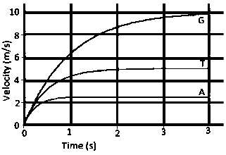
Figure 3
- Which of the liquids has the highest viscosity?
______________________________________________________________ (1 mark)
- Give a reason for the answer in 8 b. i.
____________________________________________________________________________________________________________________________________________
(2 marks)
8 continued;
c. Differentiate the terms distance and displacement.
__________________________________________________________________________________________________________________________________________________________________________________________________________ (1 mark)
- Calculate the mass of a body that accelerate from 2m/s to 8m/s when acted upon by a force of 400N for 3 seconds.

(2 marks)
- a. Describe any one property of electromagnetic waves.
____________________________________________________________________________________________________________________________________ (1 mark)
b. Mention any one detector for electromagnetic radiations associated with communication
______________________________________________________________ (1 mark)
- An object 2cm tall is placed 5cm in front of a convex lens of focal length 15cm. Using the lens formula find the position and nature of the image produced.

(3 marks)
- Give two differences between analog and digital signals.
______________________________________________________________________________________________________________________________________________________________________________________________________________________________________________________________________________________________________________________________________________________________
(2 marks)
- a. Differentiate the terms doping and rectification.
________________________________________________________________________________________________________________________________________________________________________________________________________________________________________________________________________________ (1 mark)
b. Explain how increase in temperature of a semi–conductor decreases its electrical resistance.
__________________________________________________________________________________________________________________________________________________________________________________________________________________
(2 marks)
c. Figure 5 shows is a diagram of a pulley system being used to lift a mass of 120N vertical through a height of 30m.
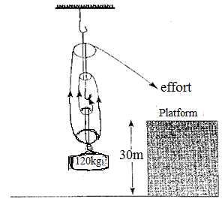
10.c continued;
Find:
    - The Mechanical advantage.

(1 mark)
    - Effort

(3 marks)

Section B (30 marks)
- a. With the aid of the given diagram of a structure of a U–tube manometer describe how it
works in determining gas pressure.
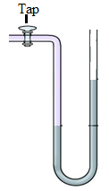
______________________________________________________________________________________________________________________________________________________________________________________________________________________________________________________________________________________________________________________________________________________________________________________________________________________________________________________________________________________________________________________________________________________________________________________________________________________________________________________
(5 marks)
b. Briefly describe how a fuse works to protect electrical appliances.
__________________________________________________________________________________________________________________________________________________________________________________________________________________________________________________________________________________________________________________________________________________________________________________________________________________________________________________________________________________________________________
(5 marks)
- a. Briefly describe an experiment that can be carried in order to determine centre of mass of
an irregular lamina using a plumb line.
__________________________________________________________________________________________________________________________________________________________________________________________________________________________________________________________________________________________________________________________________________________________________________________________________________________________________________________________________________________________________________________________________________________________________________________________________________________________________________________________________________________________________________________________________________________________________________________________________
(5 marks)
b. Describe how step down transformers work.
________________________________________________________________________________________________________________________________________________________________________________________________________________________________________________________________________________________________________________________________________________________________________________________________________________________________________________________________________________________________________________________________________________________________________________________________________________________________________________________________________________________________________________________________________________________________________________________________________________________________________________________________________
(5 marks)
- a. Explain five environmental impacts of hydroelectric power generation and transmission.
______________________________________________________________________________________________________________________________________________________________________________________________________________________________________________________________________________________________________________________________________________________________________________________________________________________________________________________________________________________________________________________________________________________________________________________________________________________________________________________
(5 marks)
b. i. Explain how liquid pressure is applied in water supply systems.
____________________________________________________________________________________________________________________________________________________________________________________________________________________________________________________________________________________________________________________________________________________
(3 marks)
- Name any two devices that work on the principle of gas pressure.
________________________________________________________________________________________________________________________________________
(2 marks)

END OF QUESTION PAPER
This paper contains 14 printed pages.

